**Laboratory work 6**

1. Write a query that displays all flights of a specific airline.

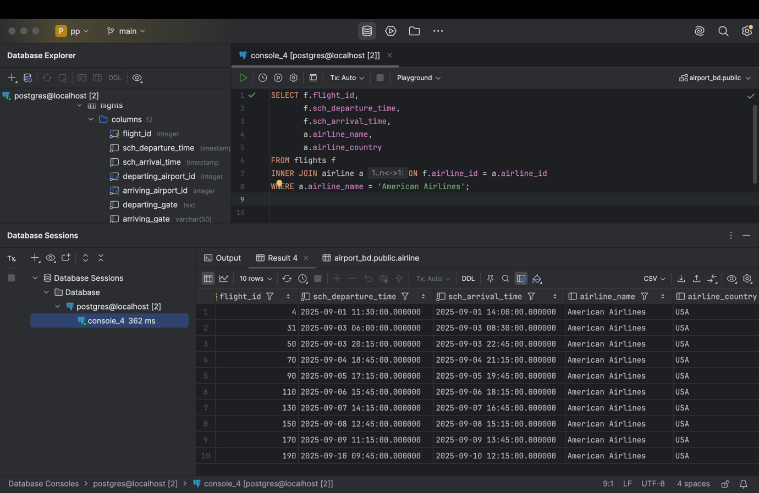

SELECT f.flight_id,  
 f.sch_departure_time,  
 f.sch_arrival_time,  
 a.airline_name,  
 a.airline_country  
FROM flights f  
INNER JOIN airline a ON f.airline_id = a.airline_id  
WHERE a.airline_name = 'American Airlines';

1. Compose a query to obtain a list of all flights with the names of departure airports.   
   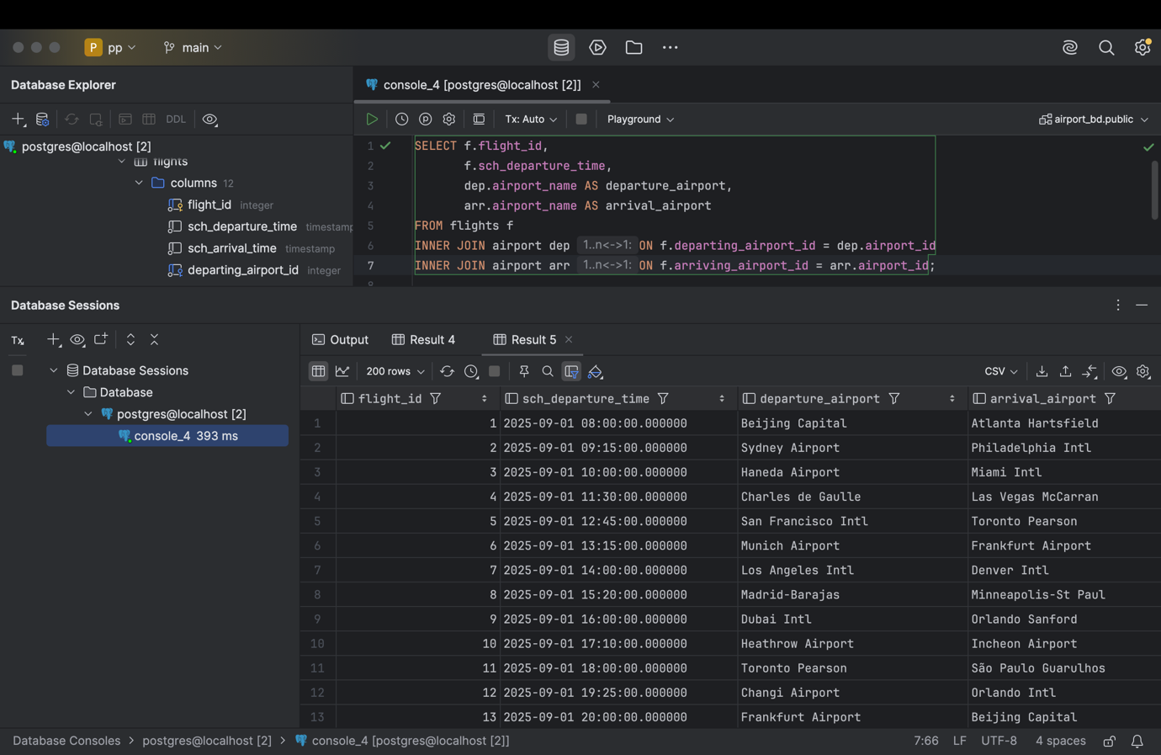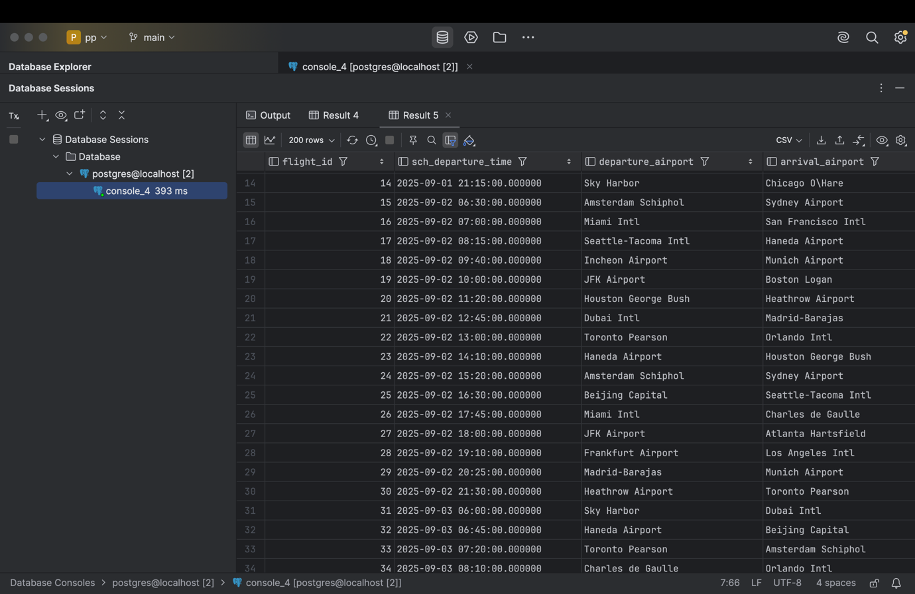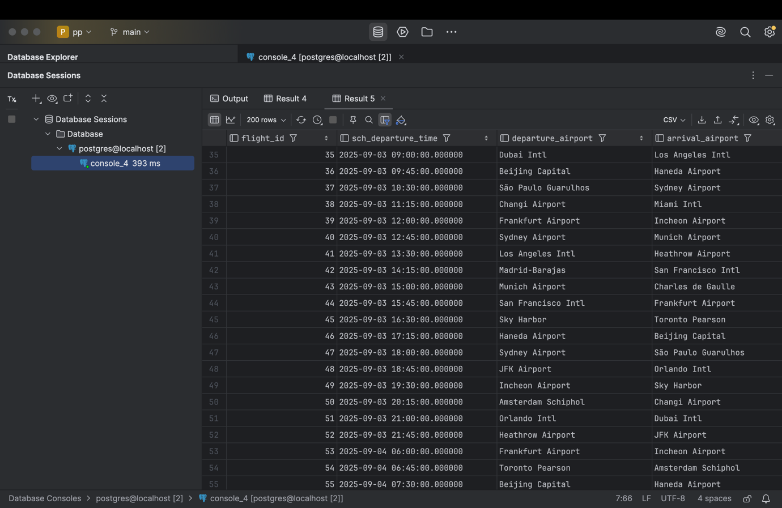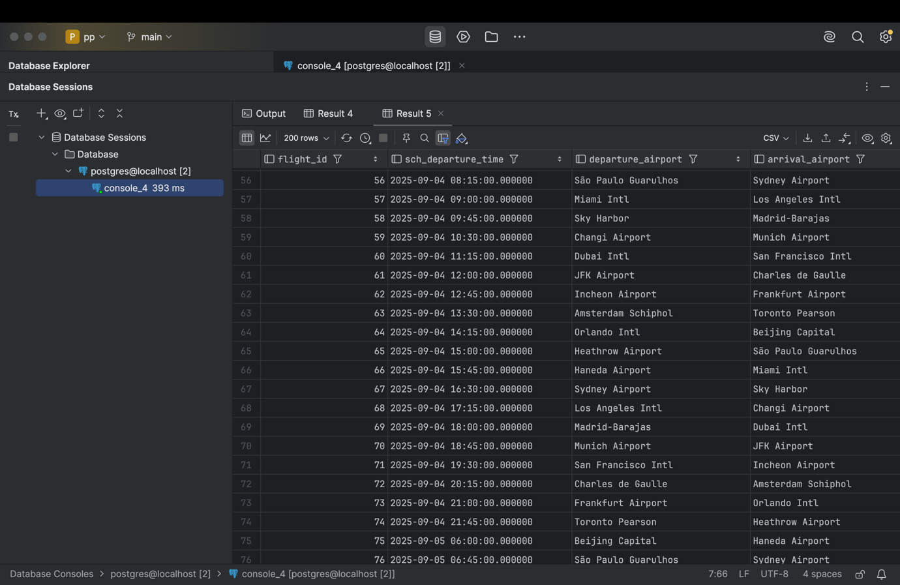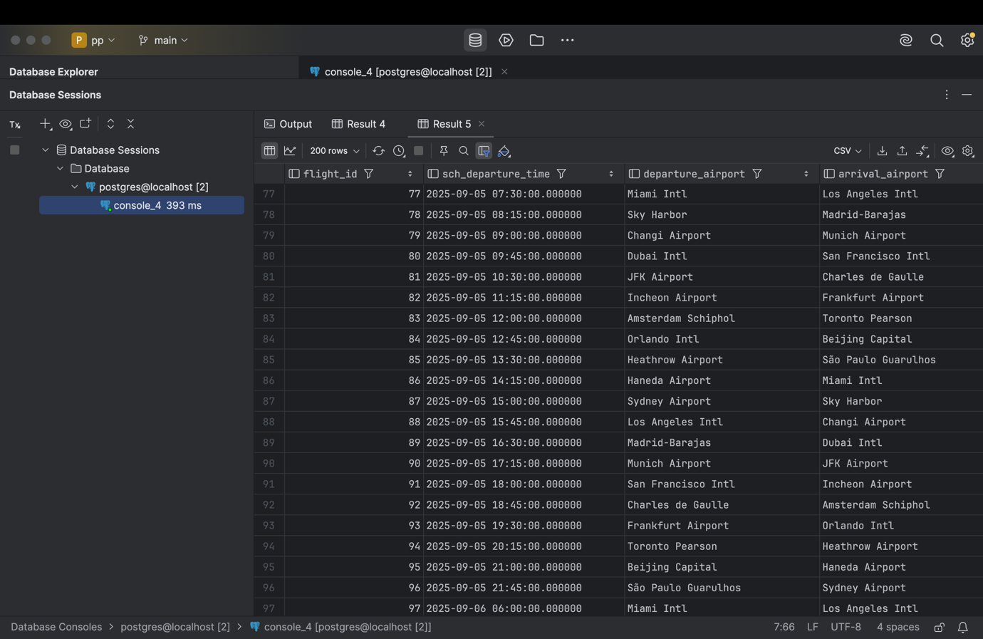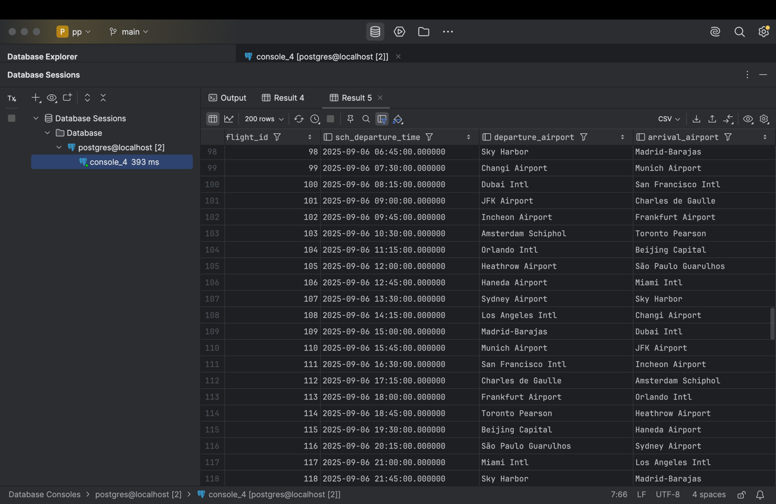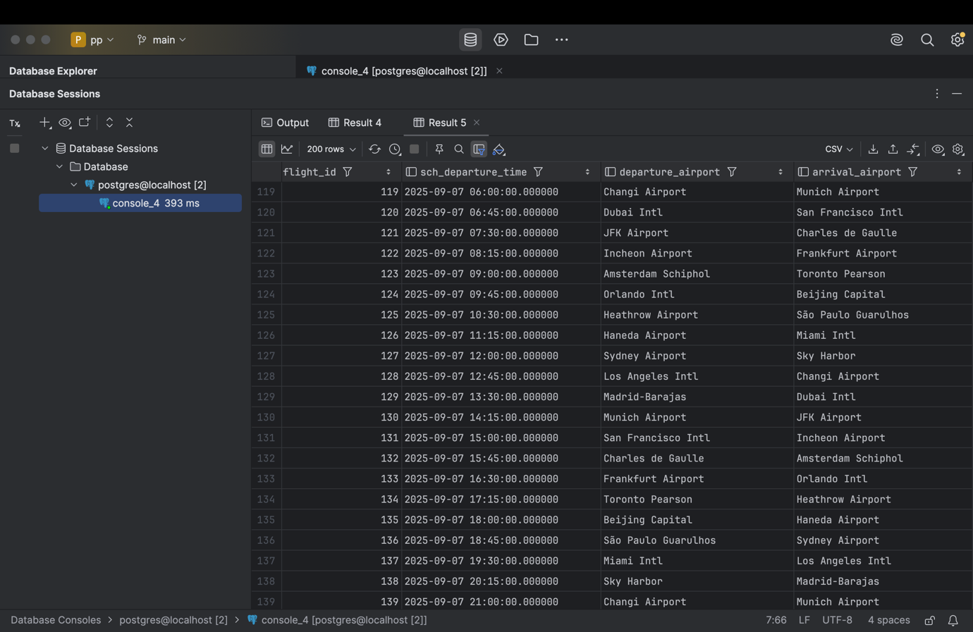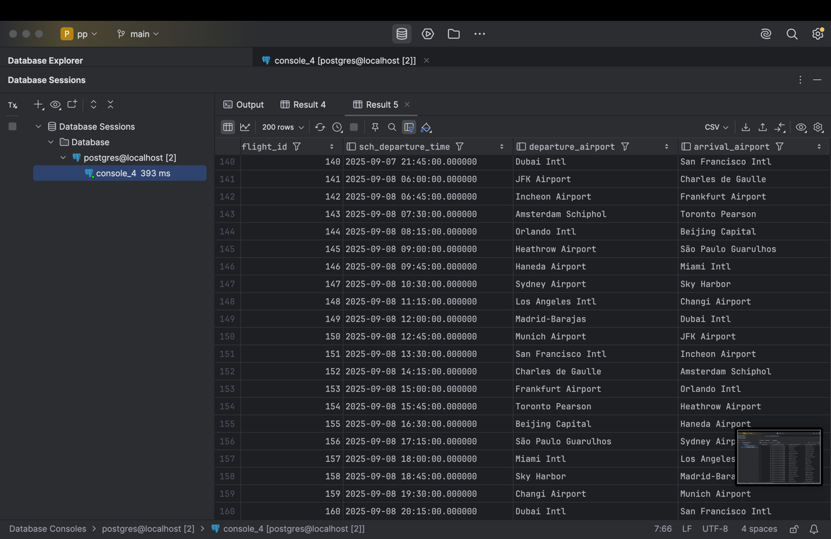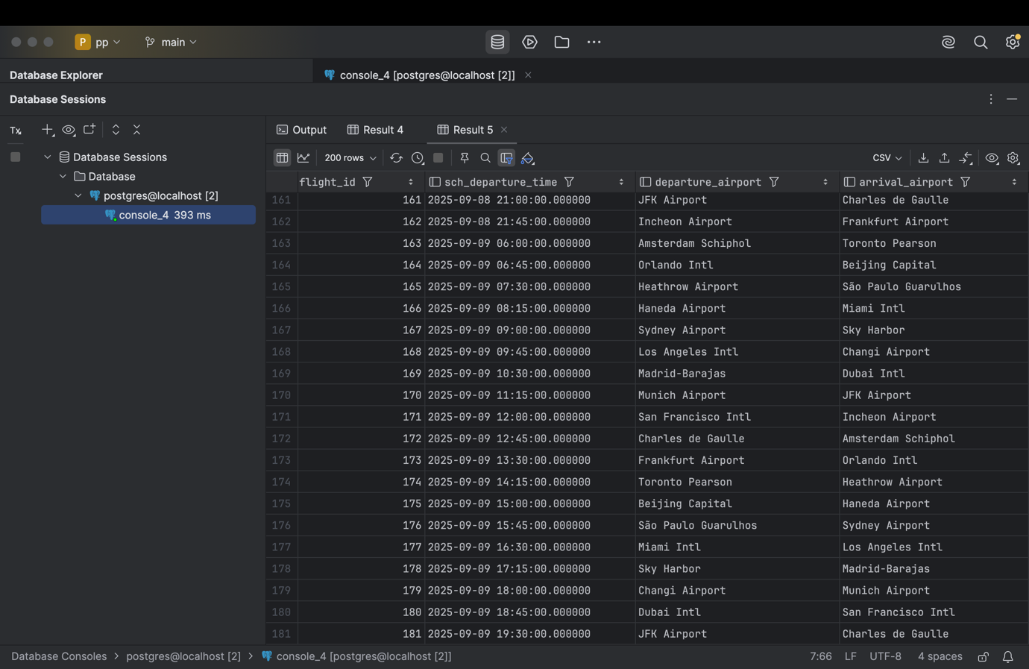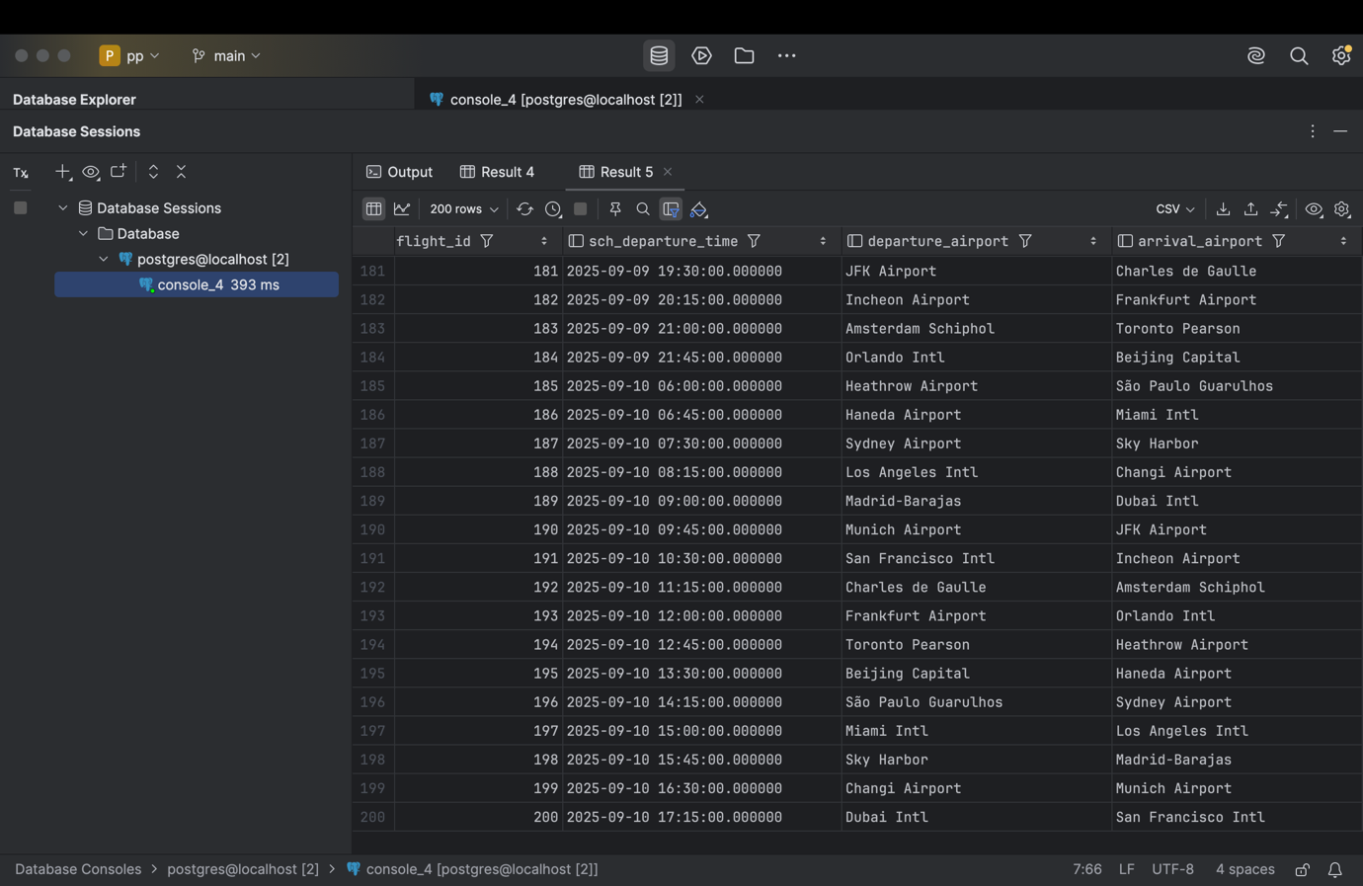

SELECT f.flight_id,  
 f.sch_departure_time,  
 dep.airport_name AS departure_airport,  
 arr.airport_name AS arrival_airport  
FROM flights f  
INNER JOIN airport dep ON f.departing_airport_id = dep.airport_id  
INNER JOIN airport arr ON f.arriving_airport_id = arr.airport_id;

1. Create a query that finds all airlines that have no flights scheduled for the next month.

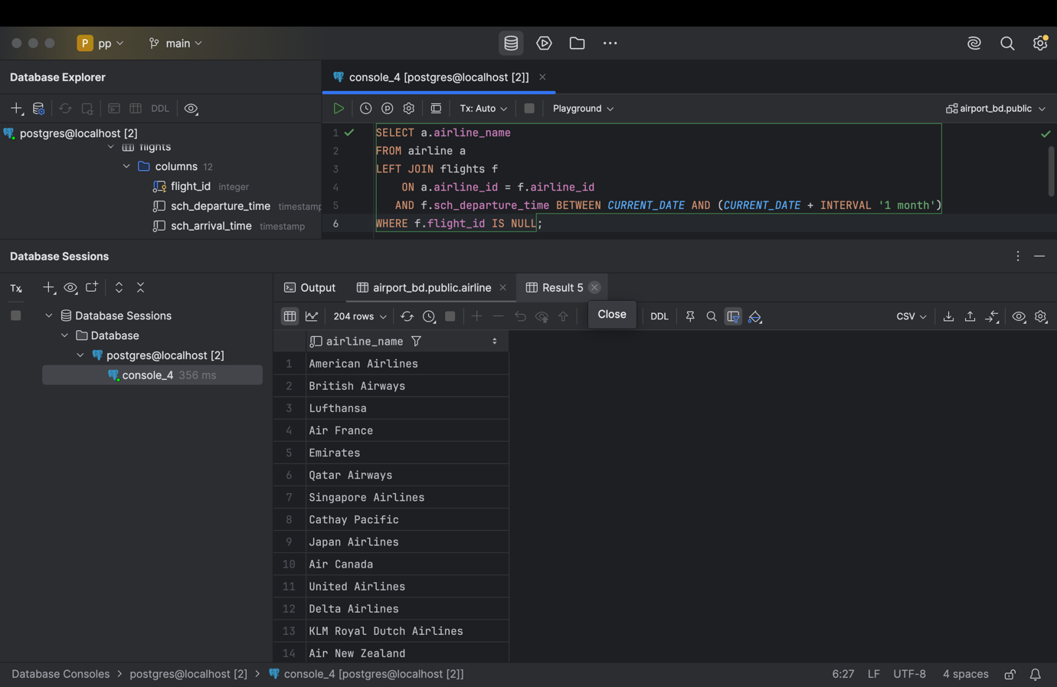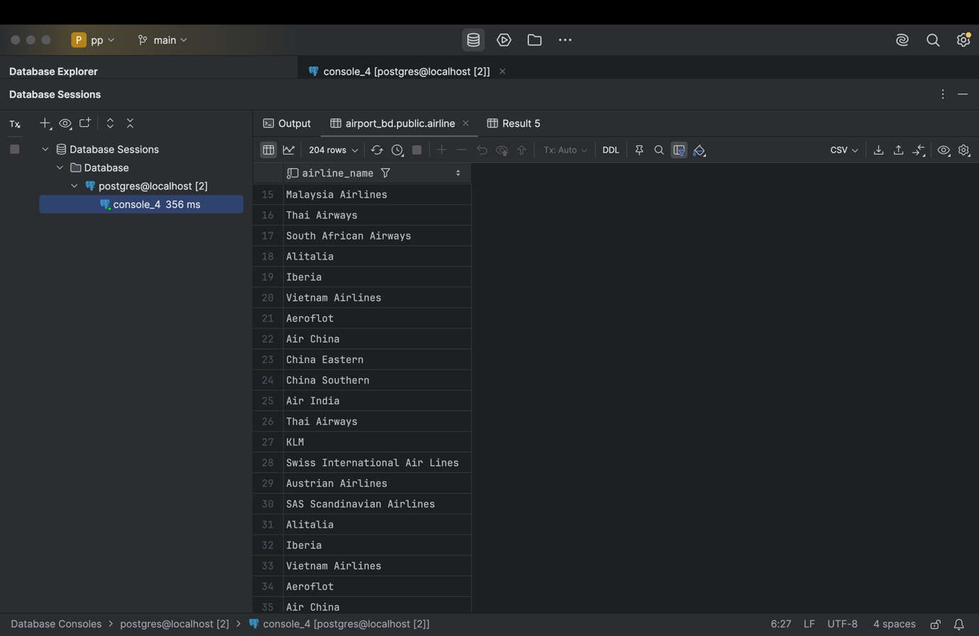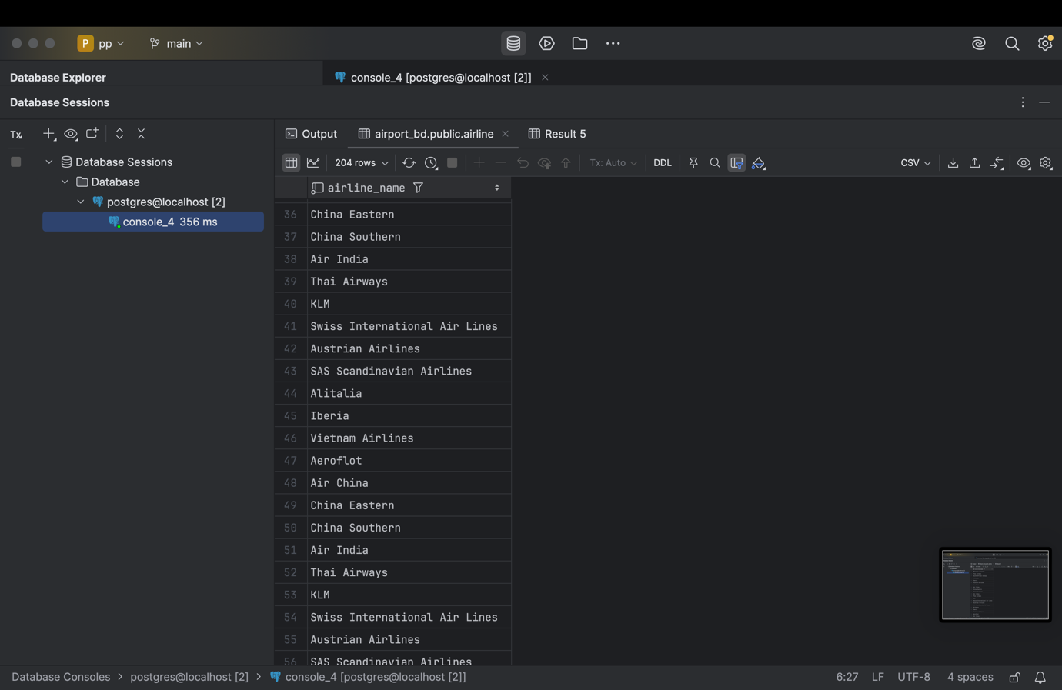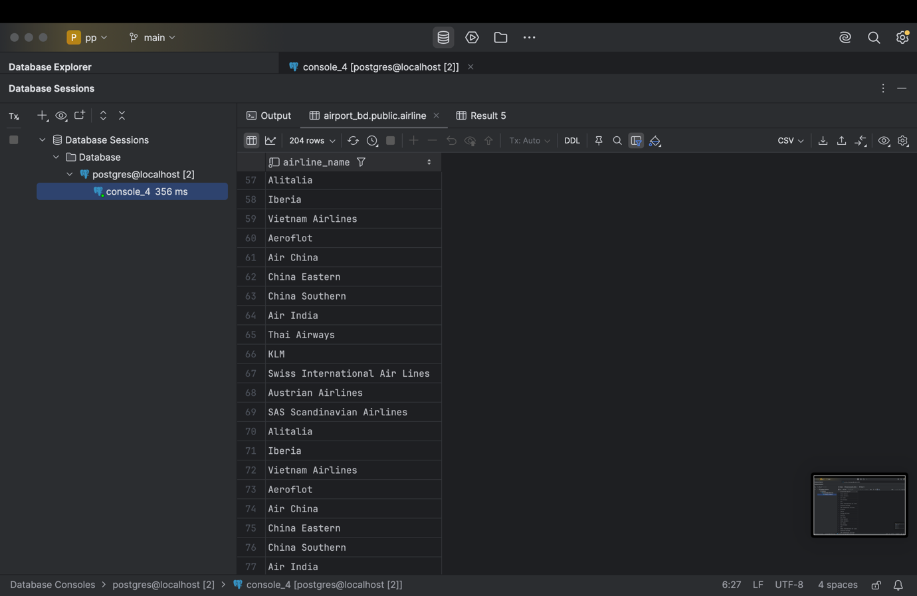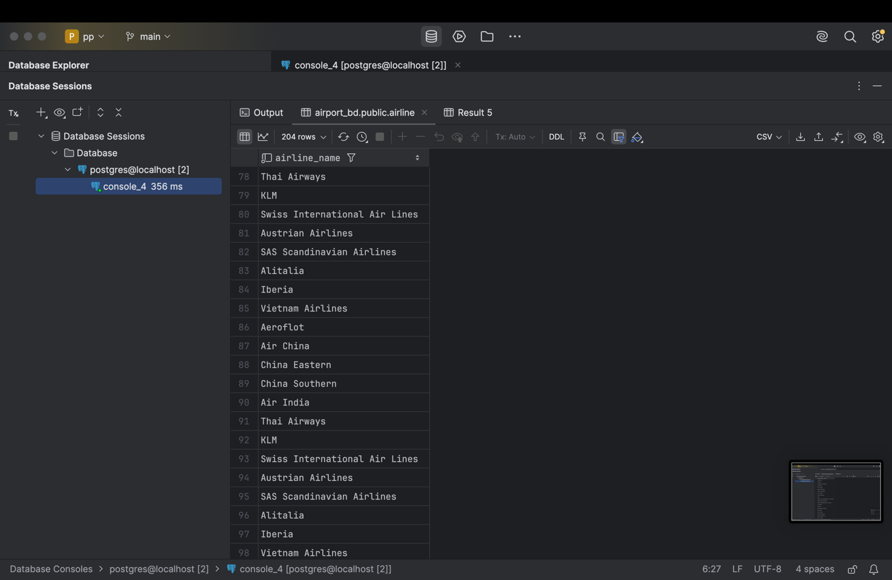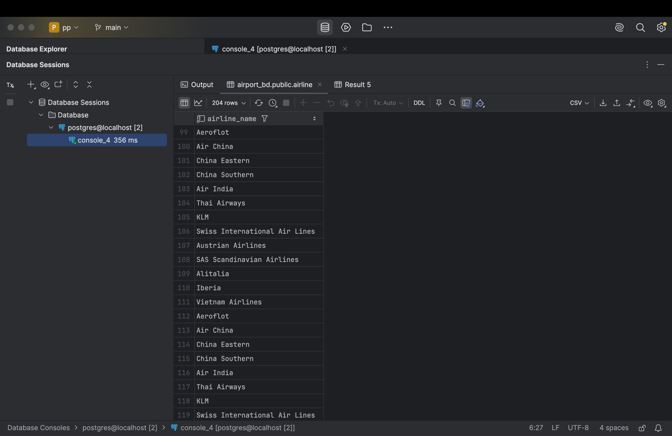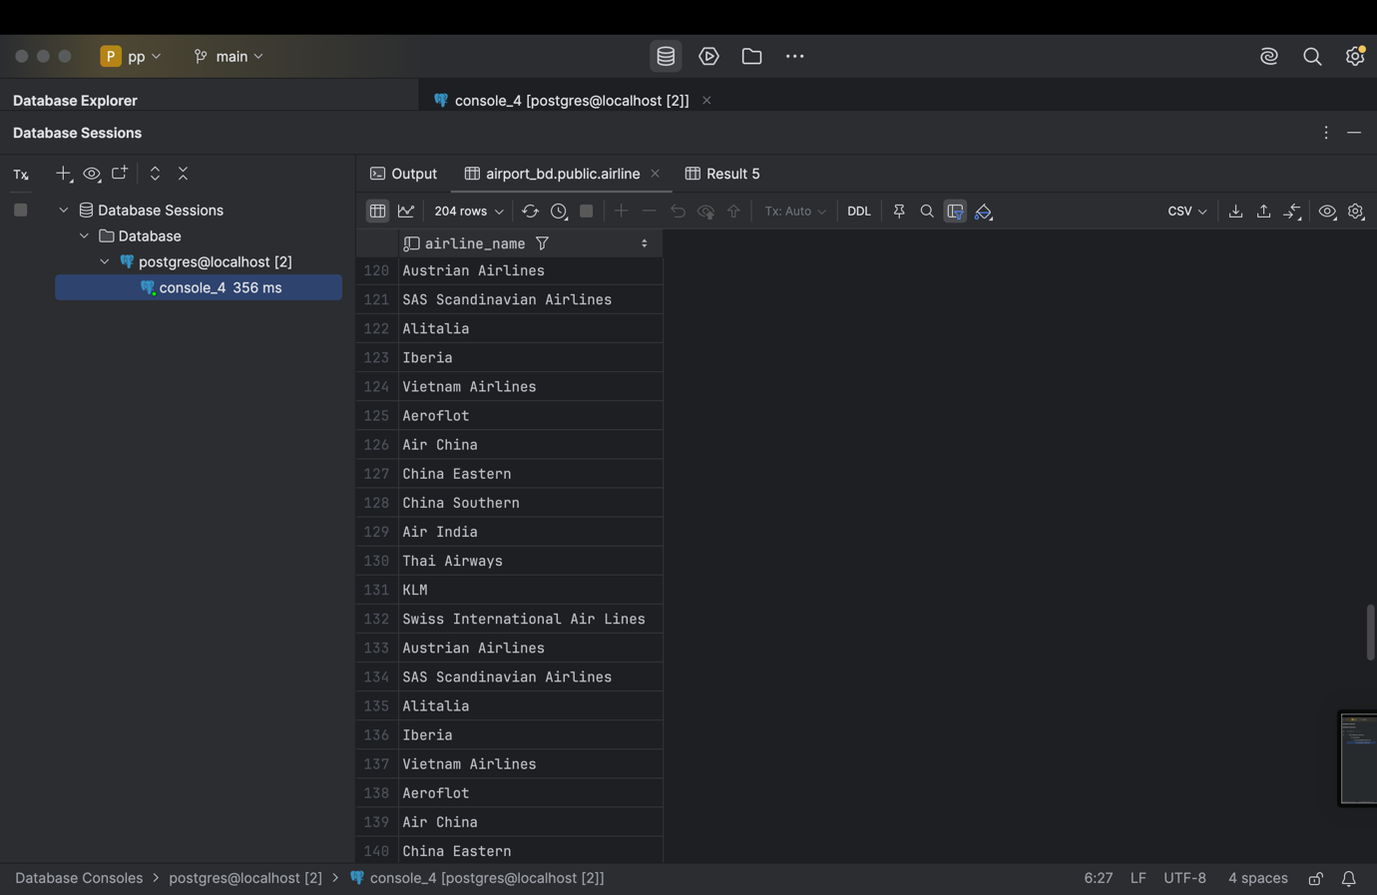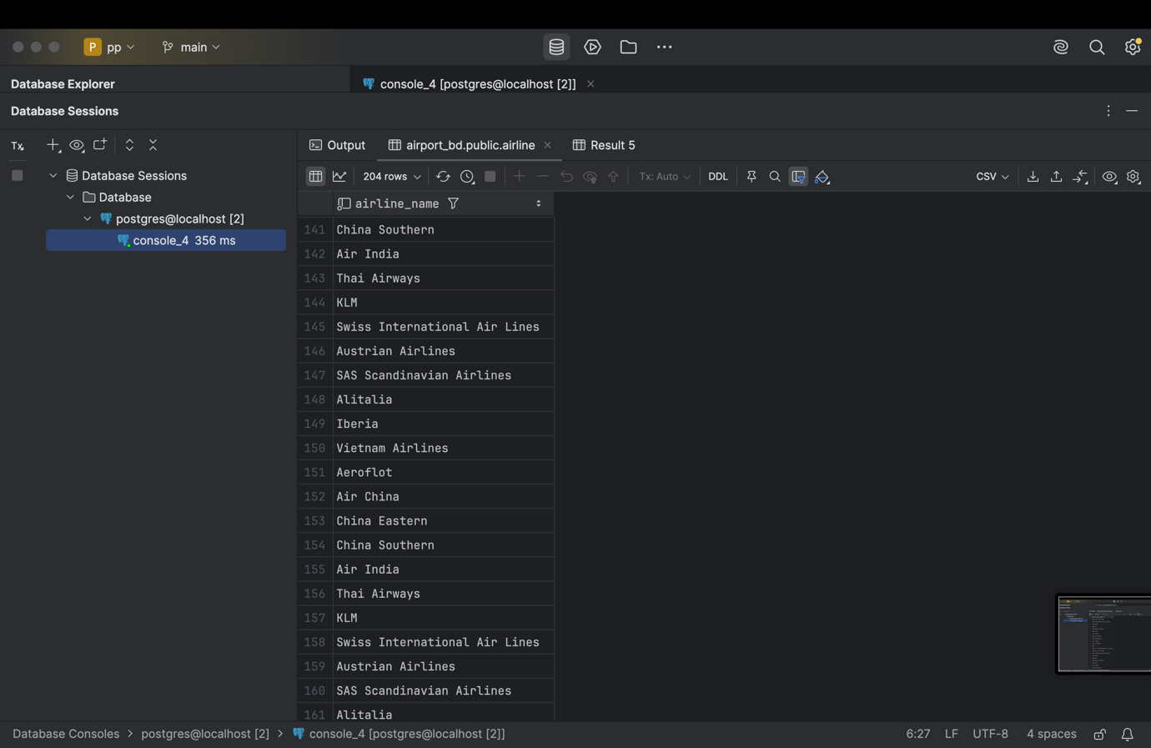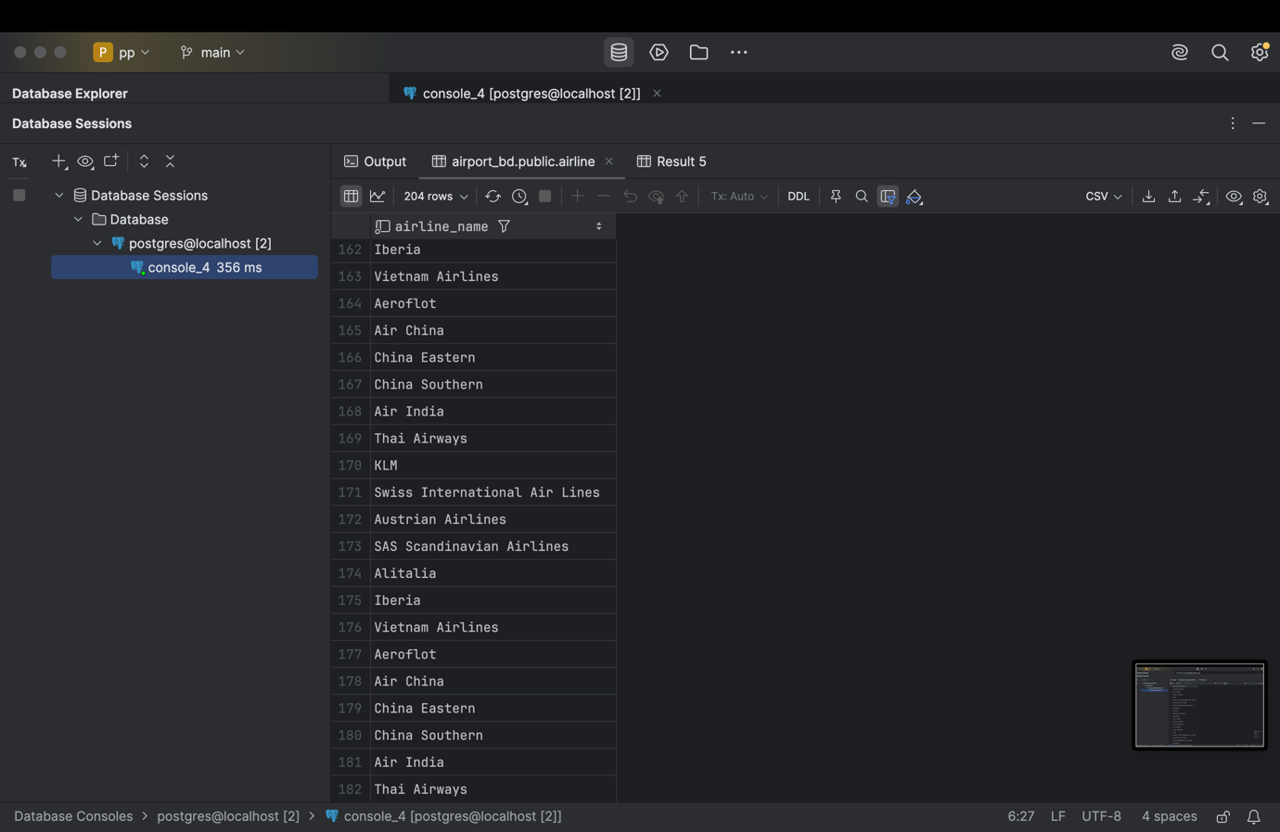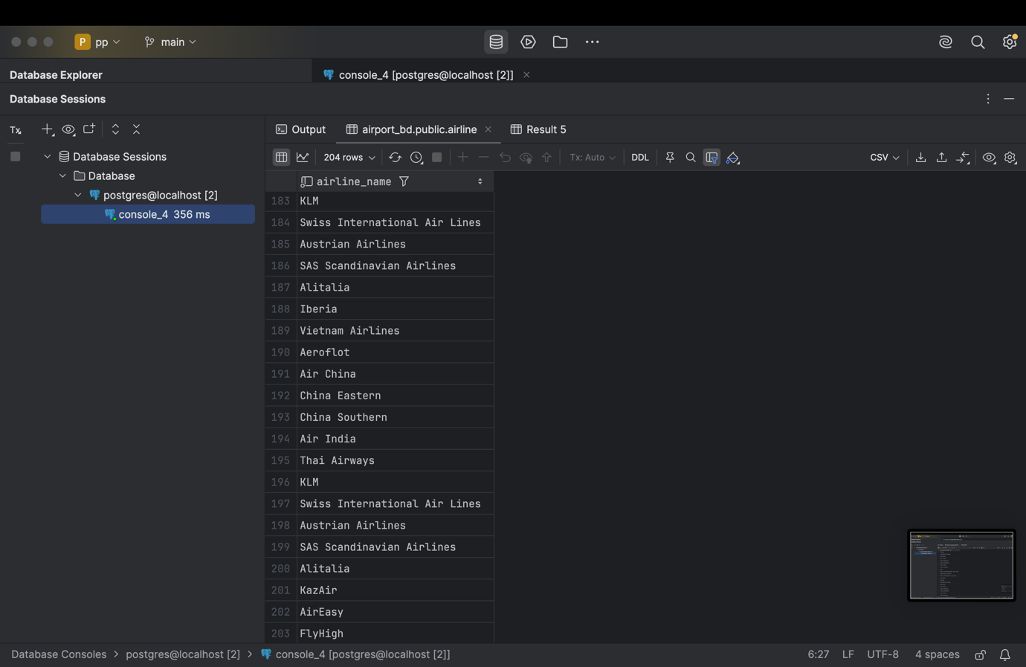

SELECT a.airline_name  
FROM airline a  
LEFT JOIN flights f  
 ON a.airline_id = f.airline_id  
 AND f.sch_departure_time BETWEEN *CURRENT_DATE* AND (*CURRENT_DATE* + INTERVAL '1 month')  
WHERE f.flight_id IS NULL;

1. Create a query to display a list of passengers on a specific flight.

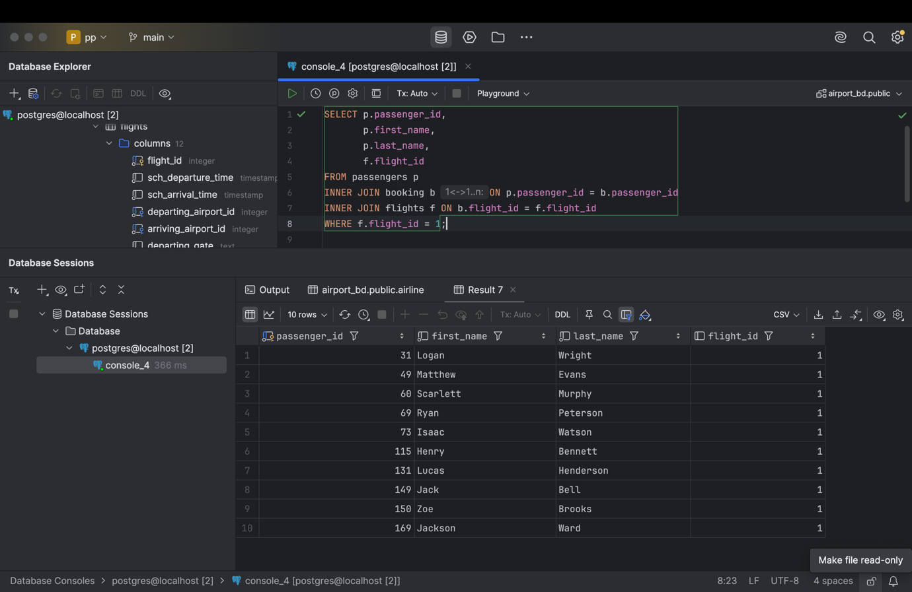

SELECT p.passenger_id,  
 p.first_name,  
 p.last_name,  
 f.flight_id  
FROM passengers p  
INNER JOIN booking b ON p.passenger_id = b.passenger_id  
INNER JOIN flights f ON b.flight_id = f.flight_id  
WHERE f.flight_id = 1;

1. Write a query that calculates the average, total, maximum and minimum price of tickets for each flight.

SELECT f.flight_id,  
 *AVG*(b.ticket_price)::NUMERIC(10,2) AS avg_price,  
 *SUM*(b.ticket_price)::NUMERIC(10,2) AS total_price,  
 *MAX*(b.ticket_price) AS max_price,  
 *MIN*(b.ticket_price) AS min_price  
FROM booking b  
INNER JOIN flights f ON b.flight_id = f.flight_id  
GROUP BY f.flight_id;

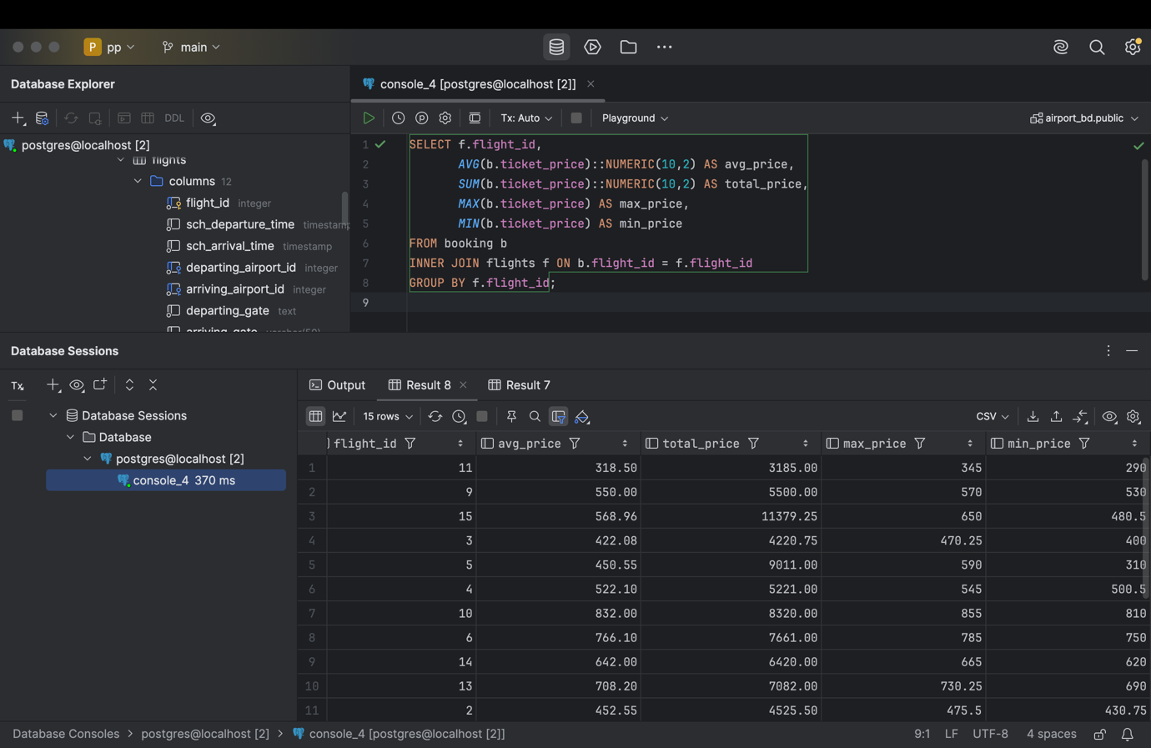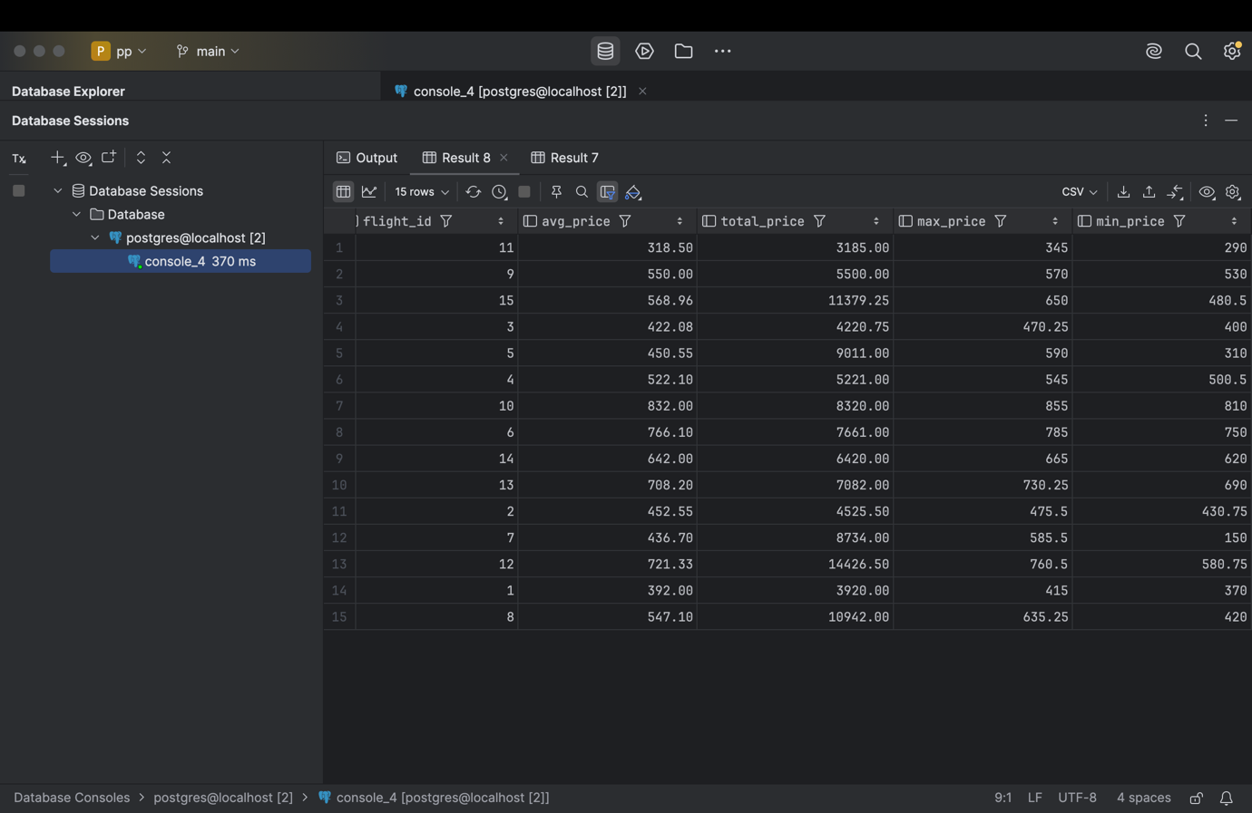

1. Create a query that shows all flights flying to a specific country by combining flights, airports and airline, and using the condition on the country name.

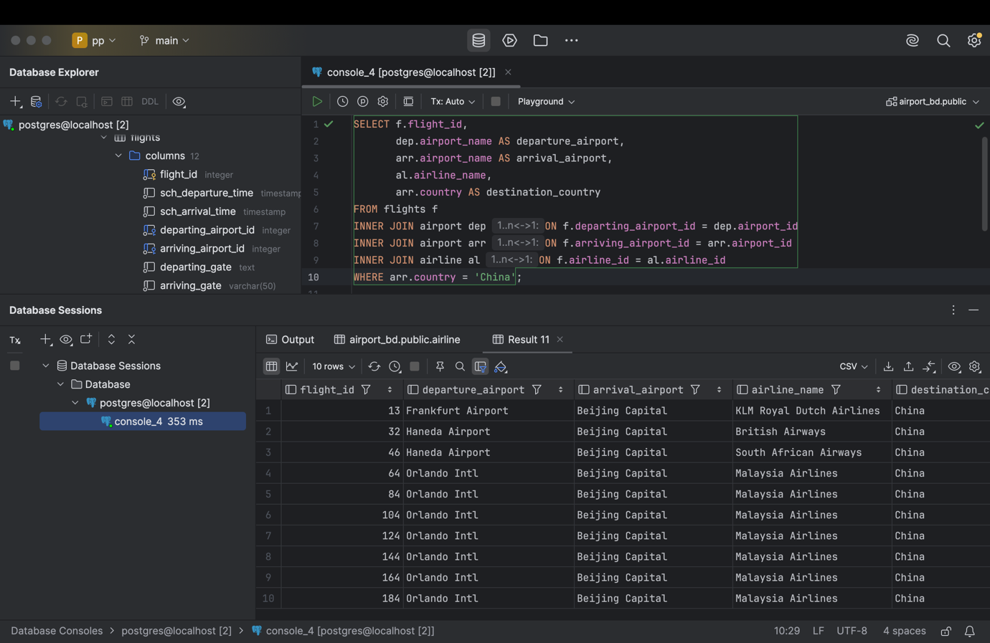

SELECT f.flight_id,  
 dep.airport_name AS departure_airport,  
 arr.airport_name AS arrival_airport,  
 al.airline_name,  
 arr.country AS destination_country  
FROM flights f  
INNER JOIN airport dep ON f.departing_airport_id = dep.airport_id  
INNER JOIN airport arr ON f.arriving_airport_id = arr.airport_id  
INNER JOIN airline al ON f.airline_id = al.airline_id  
WHERE arr.country = 'China';

1. Display a list of minor passengers and their arrival destination.

SELECT p.first_name,  
 p.last_name,  
 arr.airport_name AS arrival_airport  
FROM passengers p  
INNER JOIN booking b ON p.passenger_id = b.passenger_id  
INNER JOIN flights f ON b.flight_id = f.flight_id  
INNER JOIN airport arr ON f.arriving_airport_id = arr.airport_id  
WHERE (*DATE_PART*('year', *AGE*(p.date_of_birth)) < 18);

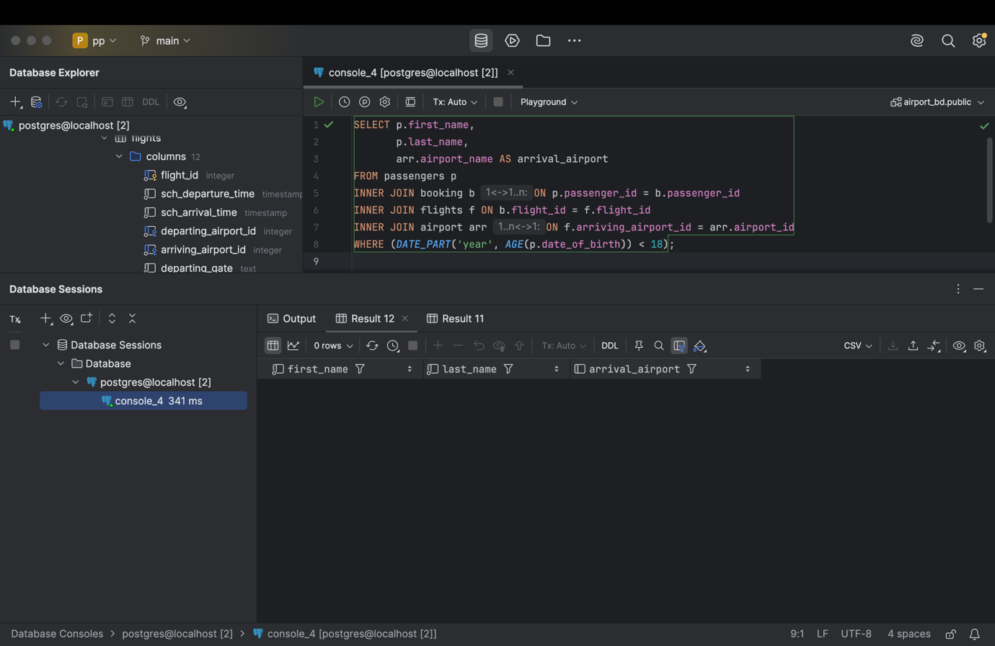

1. Display the passenger’s full name, passport number, and the passenger’s current time of arrival at the destination.

SELECT p.first_name || ' ' || p.last_name AS full_name,  
 p.passport_number,  
 f.act_arrival_time AS arrival_time  
FROM passengers p  
INNER JOIN booking b ON p.passenger_id = b.passenger_id  
INNER JOIN flights f ON b.flight_id = f.flight_id;

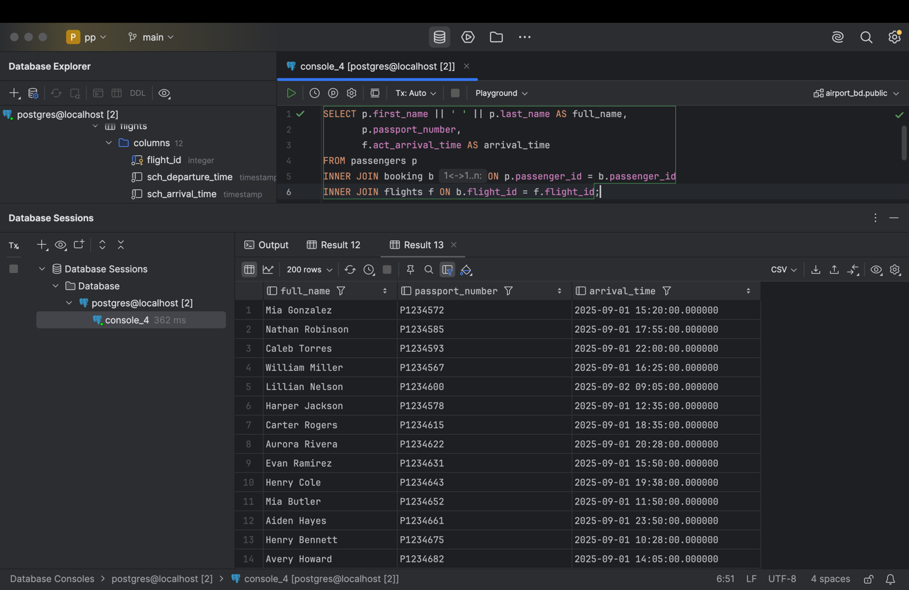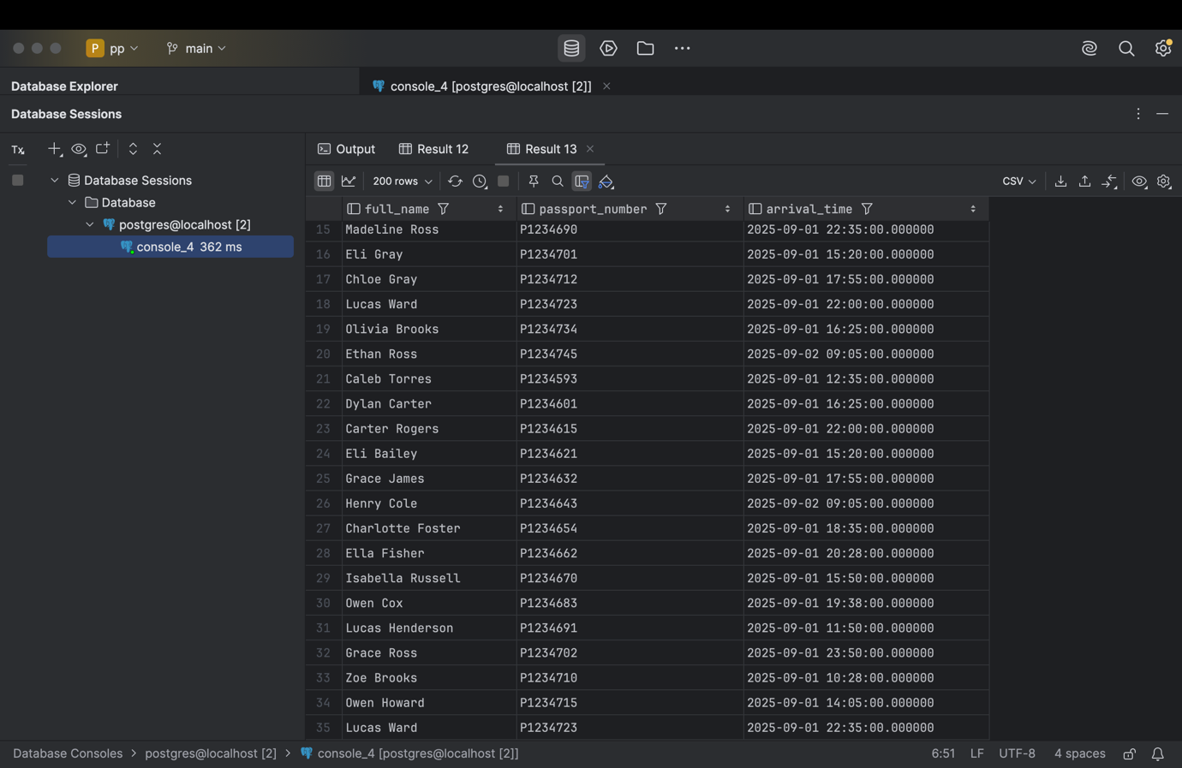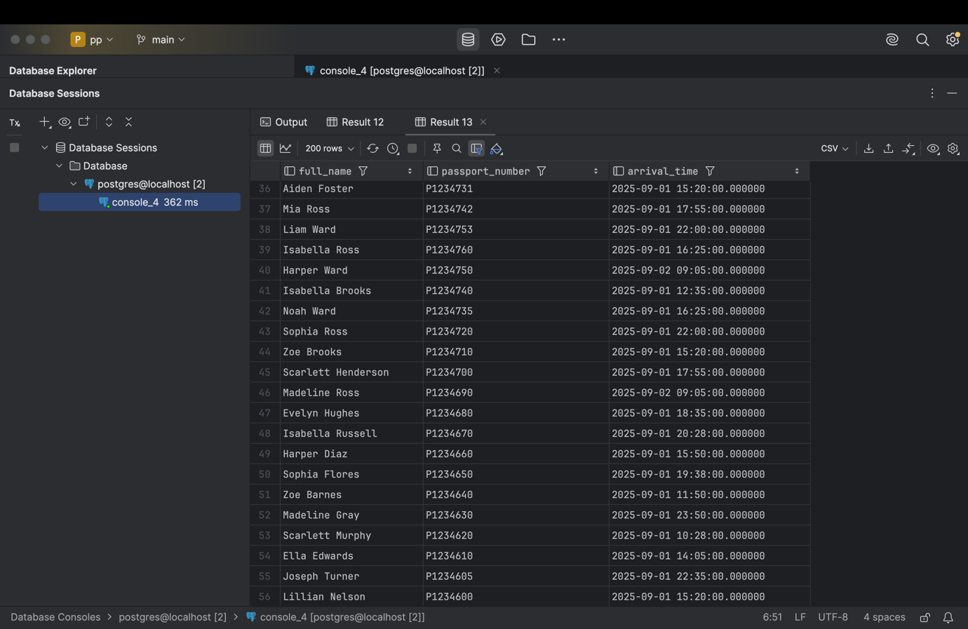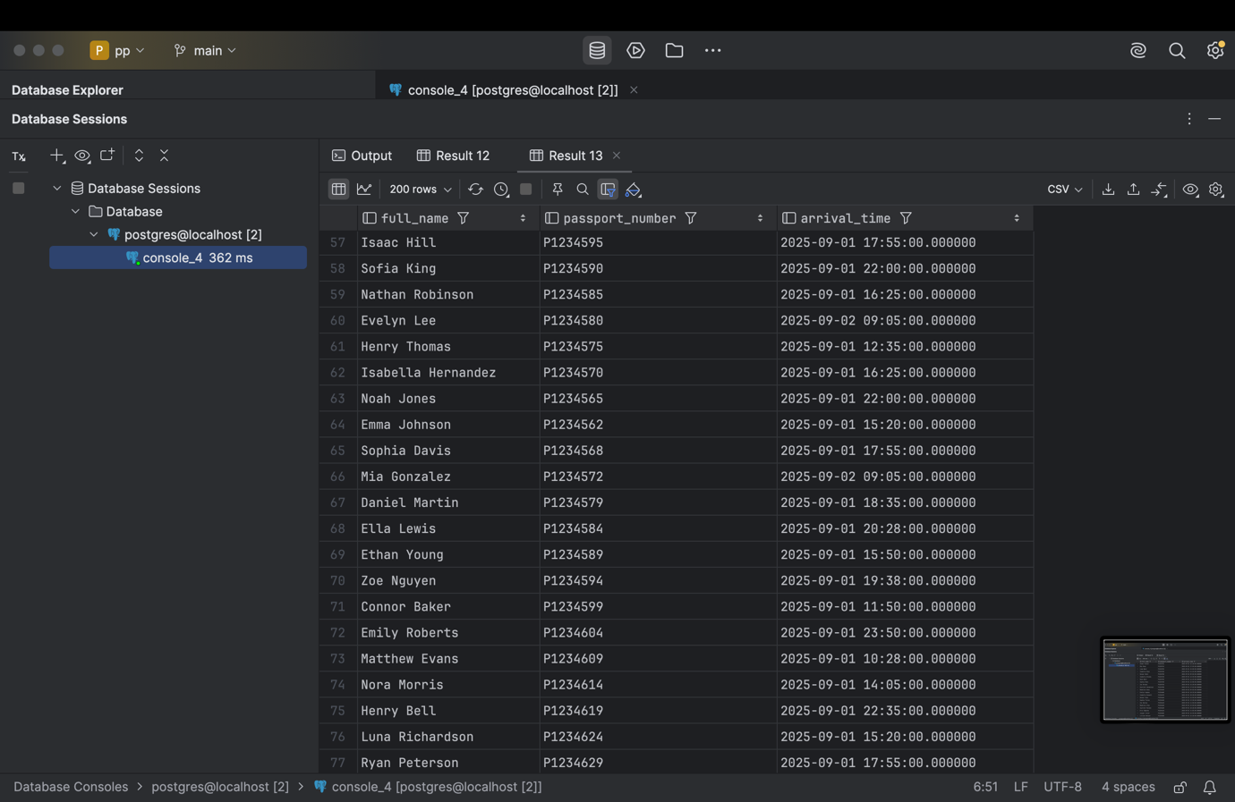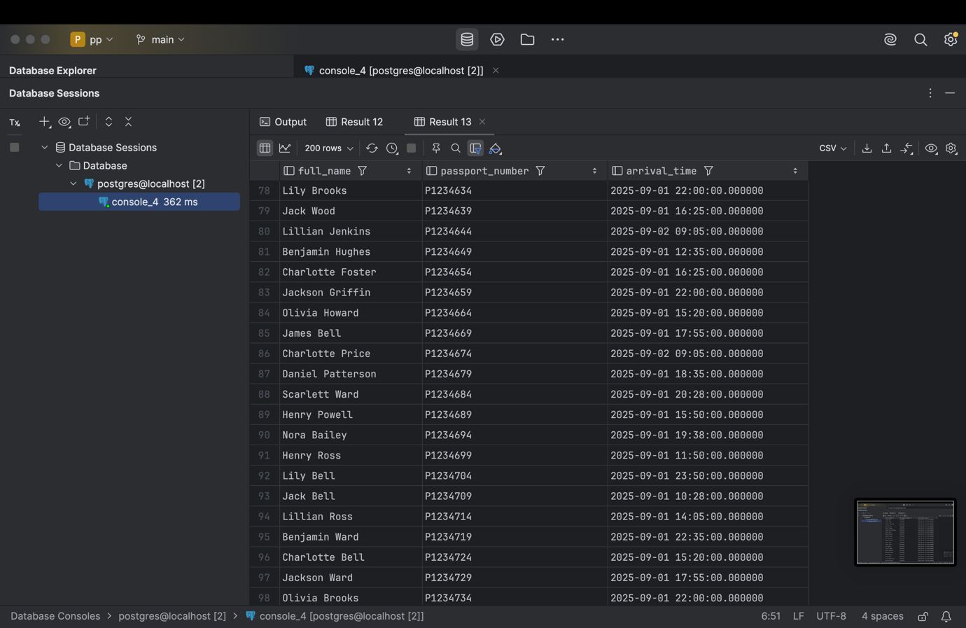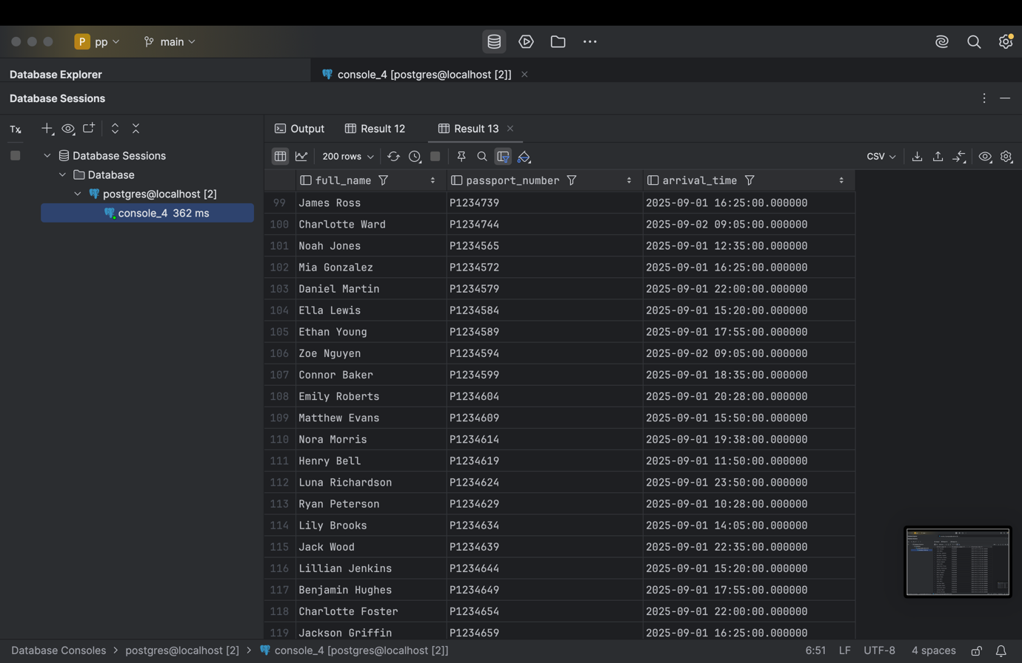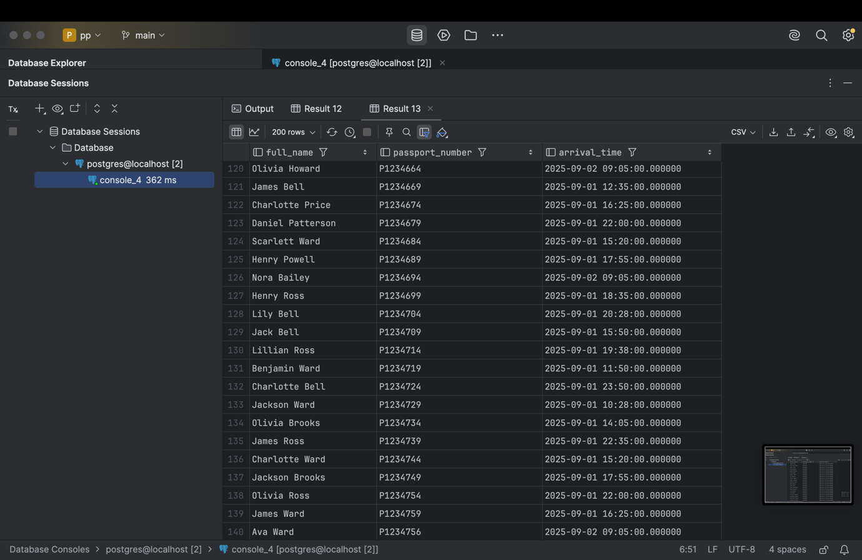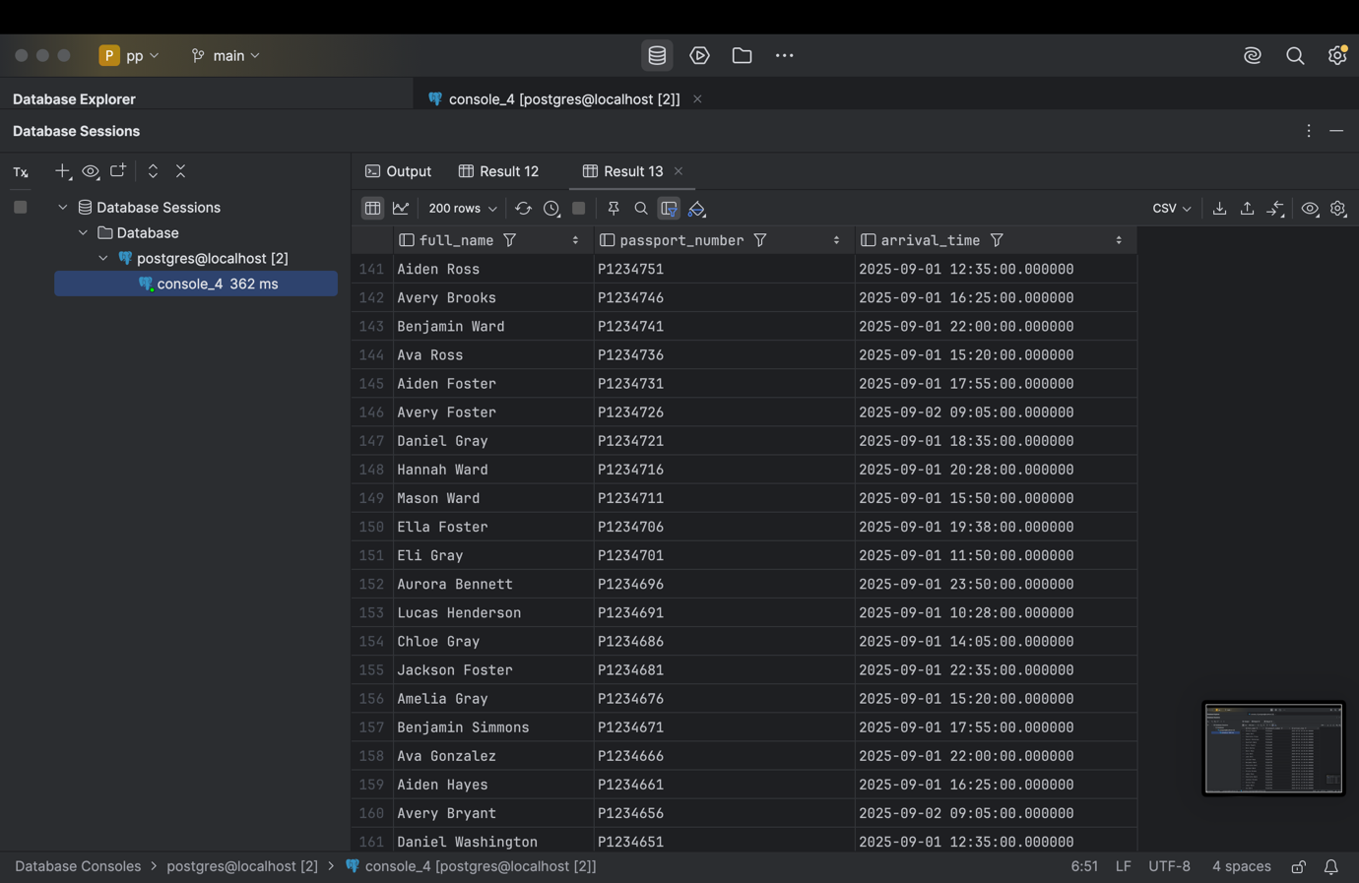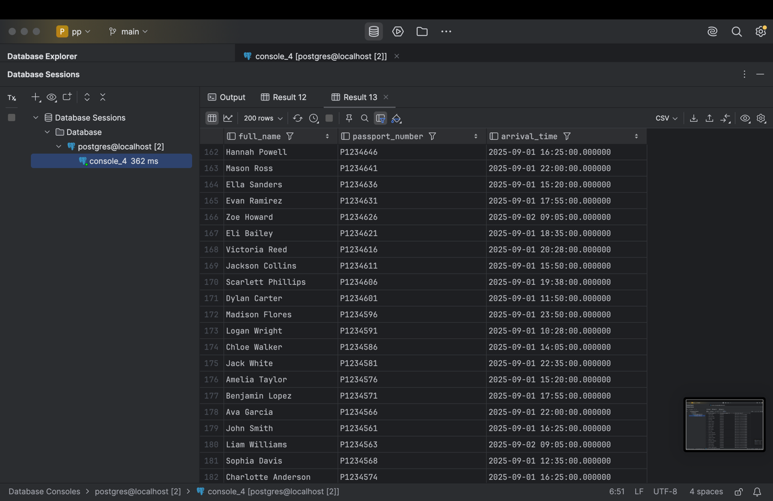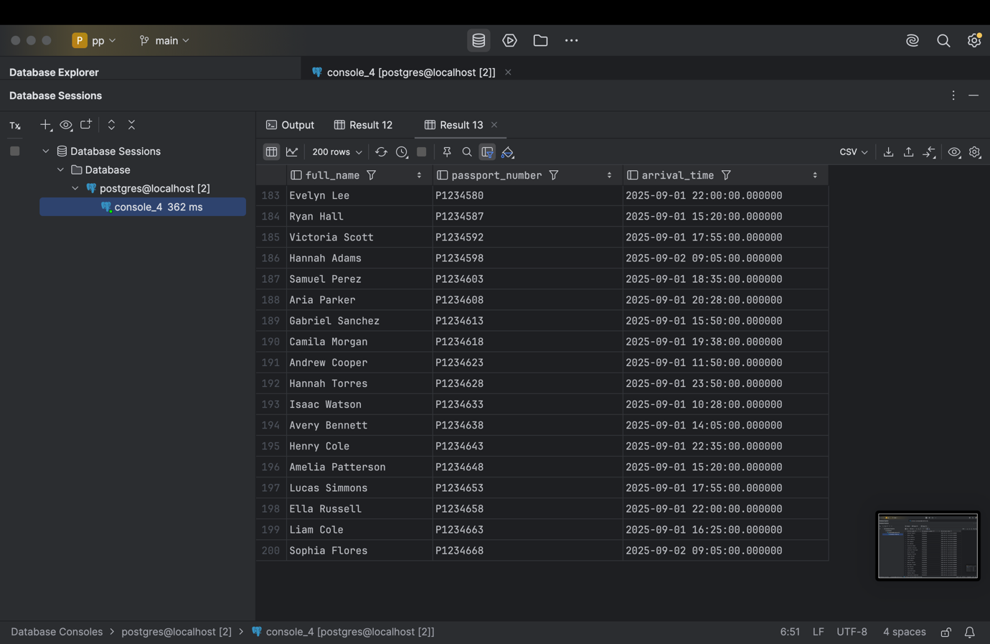

1. Print a list of flights where the airline's home country and origin country are the same. Group them by the airport country.

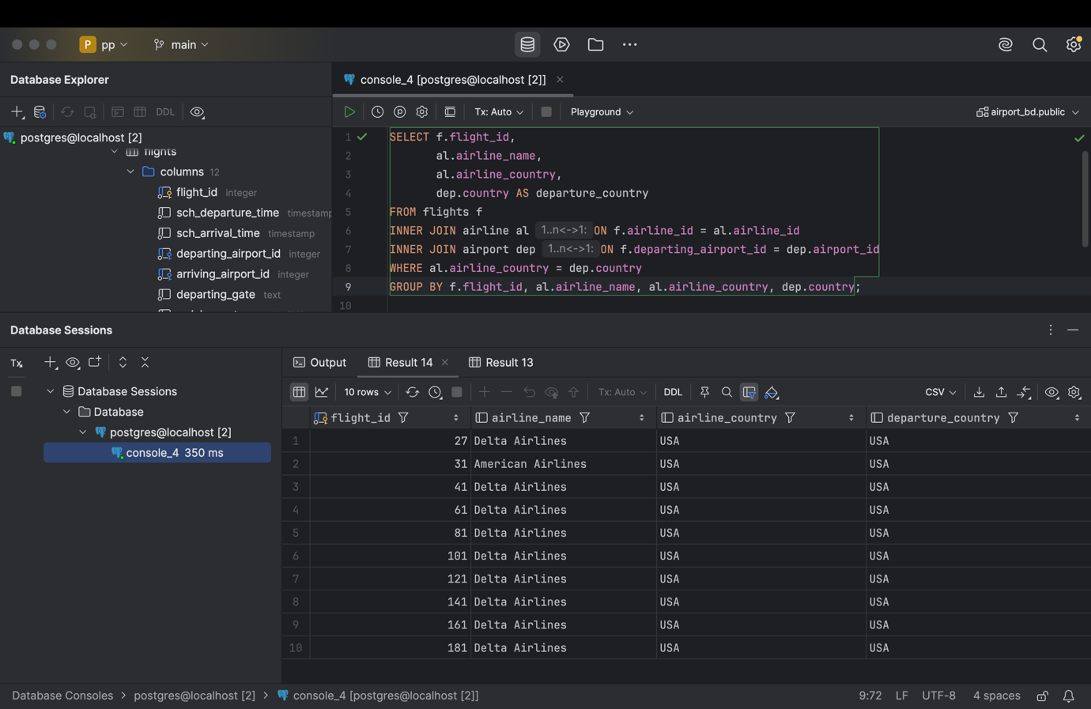

SELECT f.flight_id,  
 al.airline_name,  
 al.airline_country,  
 dep.country AS departure_country  
FROM flights f  
INNER JOIN airline al ON f.airline_id = al.airline_id  
INNER JOIN airport dep ON f.departing_airport_id = dep.airport_id  
WHERE al.airline_country = dep.country  
GROUP BY f.flight_id, al.airline_name, al.airline_country, dep.country;